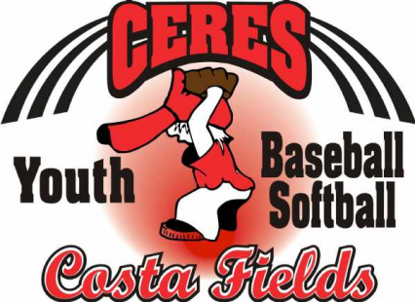

COVID 19
RETURN TO PLAY WAIVER
FOR 2021 REC. BALL, BLAZE, SIZZLE AND TRAVEL BALL SEASON
In consideration of being allowed to participate in any way in the Ceres Youth Baseball/Softball
athletics sports program, related events and activities, the undersigned acknowledges,
appreciates, and agrees that:
1. The risk of injury and/or illness from the activities involved in the program is significant,
including the potential for permanent paralysis and death, and while rules, equipment,
and personal discipline may reduce the risk, the risk of serious injury does exist.
2. The risk to have contact with individuals, who have been exposed to and/or have been.
diagnosed with one or more communicable diseases, including but not limited to COVID-19 or
other medical conditions, diseases, or maladies does exist, and it is impossible to eliminate the
risk that I could be exposed to and/or become infected through contact with or proximity.
with an individual with a communicable disease.
3. I KNOWINGLY AND FREELY ASSUME ALL SUCH RISKS, both known and unknown,
EVEN IF ARISING FROM THE NEGLIGENCE OF THE Board of Ceres Youth
Baseball/Softball or the City of Ceres and assume all full responsibility for my participation.
4. I willingly agree to comply with the stated and customary terms and conditions for
participation. If, however, I observe any unusual significant hazard during my presence or
participation, I will remove myself from participation and bring such to the attention of the
nearest official immediately; and
5. I, for myself and on behalf of my heirs, assigns, personal representatives and next of kin, and
any person or persons attending to watch my son or daughter.
I HEREBY RELEASE AND HOLD HARMLESS THE CERES YOUTH
BASEBALL/SOFTBALL, their officers, officials, agents and/or employees, other participants,
sponsoring agencies, sponsors, advertisers, and if applicable the City of Ceres to conduct the
event, WITH RESPECT TO ANY AND ALL INJURY, ILLNESS, DISABILITY, DEATH, or
loss or damage to person or property, WHETHER ARISING FROM THE NEGLIGENCE OF

THE RELEASEES OR OTHERWISE.
6. I HAVE READ THIS RELEASE OF LIABILITY AND ASSUMPTION OF RISK
AGREEMENT, BEFORE ACKNOWLEDGING THE CHECKBOX BELOW, FULLY
UNDERSTAND ITS TERMS, UNDERSTAND THAT I HAVE GIVEN UP
SUBSTANTIAL RIGHTS BY AGREEING TO IT ON MY OWN BEHALF OR ON
BEHALF OF THE YOUTH PARTICIPANT ASSOCIATED WITH THIS GUARDIAN
ACCOUNT, AND I SIGN IT FREELY AND VOLUNTARILY WITHOUT ANY
INDUCEMENT.
ACKNOWLEDGEMENT BY ADULT PARTICIPANT: By acknowledging and agreeing to
the checkbox below, I agree and verify the following: 1) I consent and agree to assume the risks.
of participation in these programs, and 2) that I specifically agree for myself, my heirs, assigns.
and next of kin, I release and agree to indemnify the City of Ceres and the Board of the Ceres
Youth Baseball/Softball from all liability’s incident to my involvement or participation
in these programs EVEN IF ARISING FROM THE NEGLIGENCE OF THE RELEASES OR
OTHERWISE.
ACKNOWLEDGMENT BY PARENTS AND/OR LEGAL GUARDIANS OF YOUTH
PARTICIPANTS: By acknowledging and agreeing to the check box below, I agree to and
verify the following: 1) I am the parent or legal guardian for the youth participant associated with
this guardian account, 2) that the date of birth of the youth participant associated with this.
guardian account is correct.
PARENT/GUARDIAN
PLAYER
COACH _________________

