Ceres Youth Baseball/Softball
P.O. Box 123
Ceres, CA 95307
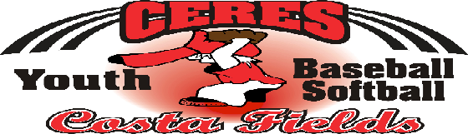

Dear Sponsor,

Ceres Youth Baseball and Softball has begun planning the 2019 season. Once again we're asking the businesses, organizations and individuals of Ceres and the surrounding areas for their much needed and appreciated help in sponsoring youth baseball and softball teams.

CYB is an independent, volunteer and non-profit organization that has for decades been dedicated to providing an organized baseball and softball program for the youth of Ceres. We now have approximately 100 teams in our program, which provides over 1,200 children the chance to participate in youth league baseball or softball. With your generous support in the form of tax-deductible team sponsorships, CYB can continue to provide these children with a wholesome, enjoyable recreational activity.

Team sponsorship fees are $275 for the first team sponsored by you and $250 each for any additional teams.
Your team sponsorship pays mainly for the team uniforms and a small portion goes toward the ongoing cost of sports equipment. The name of your business or organization will be displayed in block letters on the uniform shirts worn by the players and coaches of the team you sponsor. So everyone will know who our generous sponsors are, a list of sponsors is also prominently displayed on our bulletin board in the ballpark throughout the season.

If you would like to sponsor one or more CYB teams, please fill out and return the enclosed Sponsorship Form. To ensure we have enough time to print your name on the team uniforms, sponsorship fees should be paid prior to March 1st, 2019. To ensure fairness, the choice of team names and colors are given on a first-paid first-to-choose basis. If you have any questions, please contact the sponsorship commissioner listed below.

Ceres Youth Baseball & Softball also offers space for field advertising signs. If you are interested in field sign advertising or if you are already an advertiser, and have questions about this please feel free to ask the sponsorship commissioner.

On behalf of Ceres Youth Baseball & Softball—and all of the kids—Thank you for your support.

Sincerely
Gina Nilsson
Sponsorship Commissioner & Uniforms Coordinator

E-mail: gnilssoncyb@gmail.com
Phone: 209-484-8834

Ceres Youth Baseball / Softball
Gina Nilsson
P.O. Box 123
Ceres, CA 95307

