GALLOWAY UNITED SOCCER SPONSORSHIP FORM
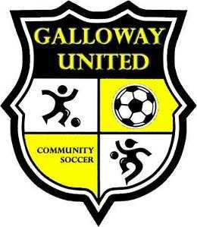

Name of Company or Sponsor: (Please print name as you would like placed on Uniforms)
_______________________________________________________________________

Name of Team/Coach requesting to Sponsor if applicable:
________________________________________________________________________

Number of Teams Sponsoring: ________

1 Team - $200
2 Team - $350
Division – Contact Board Member for cost

Please list any other requests: ____________________________________________________________________________________________________________________________________________________________________________________________________________________________________________________________________________________________________________________________________________________

- Sponsorship of a team(s) will allow for sponsor name and number or other 1 line item.

Galloway United Soccer would like to thank you for your sponsorship and support of youth soccer.

