GALLOWAY UNITED SOCCER SPONSORSHIP FORM
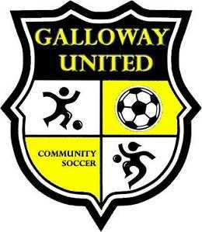

Name of Company or Sponsor: to be placed on GUCS Website with URL Link of company
_______________________________________________________________________

Contact Person: ___________________________
Contact Number: __________________________

$200 for one season (Fall or Spring Season)
$300 for two seasons
*Your business will also be posted on GUCS Facebook throughout the season

Please list any other requests: ____________________________________________________________________________________________________________________________________________________________________________________________________________________________________________________________________________________________________________________________________________________

Galloway United Soccer would like to thank you for your sponsorship and support of youth soccer.

