Help support PRLL with advertisement sponsorship.
These banner type sponsorships are a great way to get your company and information prominently displayed at our League complex. Banners are custom made and approved by you before they are printed. All sponsorship is tax deductible.
The cost for a new banner is only $325.00 ($175 to have banner printed and $150 for the sponsorship). Below is a sample Banner from one of our sponsors.
Any extra artwork is subject to a $50.00 design fee.
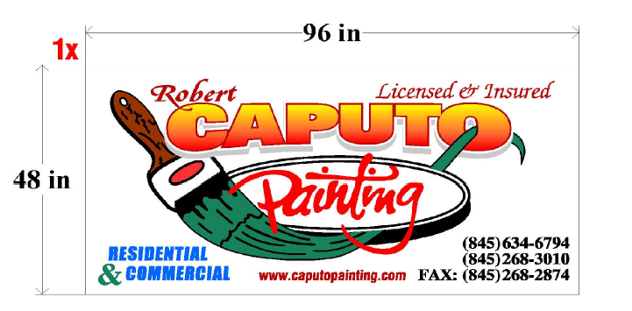
Please include your email address, so that we can send you a proof of your banner.
Name
Business Name
Address
City State Zip Code
Phone Number
Email Address
Please make checks payable to: Pearl River Little League
Mail form and check to: PRLL P.O. Box 125, Pearl River, NY 10965
THANK YOU FOR YOUR SUPPORT

